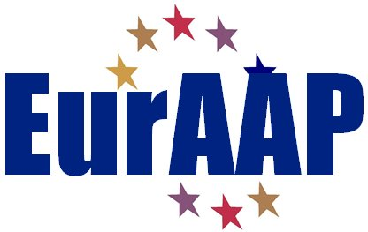

NOMINATION FORM FOR THE
2016 EurAAP LEOPOLD B. FELSEN AWARD

Nominee
  - Name: Name
  - Professional Affiliation and Title: Affiliation & Title
  - Address:
Address.
  - E-mail: e-mail.
  - Education (Institution, location, degree, and year received)
Education.
  - Short CV (biographical note):
CV.
  - Description of current activities:
Activities.
  - Achievements pertinent for the Award and justification of their relevance:
Achievements.
  - List of three relevant publications (please include them as annex)
List of publications

NOMINATOR
  - Name: Name.
  - Professional Affiliation and Title: Name.
  - Address:
Name.
  - E-mail: Name.
  - Relationship to the Nominee:
Relationship.

Endorsers (maximum 3)
Names, addresses, and emails

Note: the entire nomination form, with the exception of the endorsement letters and the publications, should not exceed five pages in length (minimum 10 point font size).

Please complete the form and send it as PDF to:

Prof. Vicenzo Galdi
vgaldi@unisannio.it

With copy to:

Dr. Marta Martínez Vázquez
marta.martinez@imst.de

Prof. Juan R. Mosig
Juan.mosig@epfl.ch

Dr. Cyril Mangenot
Cyril.Mangenot@esa.int

Endorsement letters may accompany the nomination or be sent separately. The listed publications must be included in the submission.
The nominator is responsible for submitting all the materials.

